Process Flow Documentation: Hezop PID Reader
From Static Drawings to Dynamic Plant Intelligence

Document Version: 1.0
Date: October 26, 2023
Author: Engineering & Product Team, Hezop
Project: PID Reader - AI-Powered P&ID Digitization Engine

Table of Contents
- Executive Summary & Introduction
- Understanding the Legacy Process: The Manual P&ID Workflow
- The Hezop Solution: High-Level AI Pipeline Overview
- Stage 1: Input Ingestion & Pre-Processing
- Stage 2: Vision & Symbol Recognition Layer
- Stage 3: Text Detection, OCR & Entity Disambiguation
- Stage 4: Relationship Mapping & Graph Construction
- Stage 5: Structured Data Output & Validation
- Stage 6: Integration & Downstream Application Flow
- System Architecture & Data Flow Diagram
- Future Roadmap & Advanced Process Flows
- Conclusion: The New Digital Workflow

1. Executive Summary & Introduction
Process and Instrumentation Diagrams (P&IDs) are the foundational blueprints of any process plant (chemical, oil & gas, power, pharmaceutical). They represent the intricate network of equipment, piping, instruments, and control loops that define a plant's operational logic. However, in their native form—as PDFs, scanned images, or CAD files—they are static, visual documents, not dynamic, queryable data.
The Hezop PID Reader project is engineered to bridge this critical gap. This document details the end-to-end process flows that transform an unstructured P&ID drawing into a structured, intelligent, and actionable digital asset. The core process is an AI-powered pipeline that automates the interpretation, extraction, and contextualization of every element within a P&ID, enabling a paradigm shift from manual review to automated intelligence.
The following sections will dissect this transformation through detailed process flow descriptions and supporting diagrams.
2. Understanding the Legacy Process: The Manual P&ID Workflow
To appreciate the automation, one must first understand the manual, time-intensive, and error-prone process it replaces.
Process Flow: Manual P&ID Interpretation & Data Entry
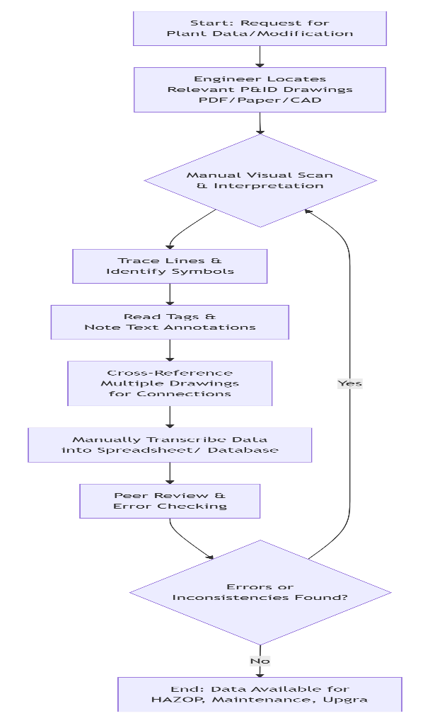

Description:
This manual workflow is linear and iterative, heavily reliant on human expertise. An engineer receives a request (e.g., for a maintenance procedure or a HAZOP study). They must:
- Locate the correct drawing set, often across disparate archives.
- Visually parse the drawing, mentally categorizing symbols (pump, valve, sensor).
- Manually read and transcribe alphanumeric tags (P-101, TV-204) and line numbers.
- Infer relationships by following flow lines with their eyes, often jumping between drawing sheets.
- Document findings in an unstructured or semi-structured format (Excel, notes).
- Undergo lengthy reviews to catch transcription errors or misinterpretations.
Key Pain Points in this Flow:
- Bottleneck at Human Interpretation: Speed is limited by engineer availability and focus.
- High Error Probability: Misreading a tag (e.g., B for 8) or missing a connection is common.
- No Single Source of Truth: Data extracted by different engineers can vary.
- Knowledge Silos: Critical understanding resides only in the minds of experienced personnel.
- Zero Reusability: The effort is replicated for every new project or analysis.
3. The Hezop Solution: High-Level AI Pipeline Overview
The Hezop PID Reader automates the core interpretive steps of the manual workflow through a staged, AI-driven pipeline.
High-Level Process Flow: Hezop PID Reader AI Pipeline
Description:
This linear pipeline represents the batch transformation of a drawing. It is a one-to-one transformation process where each stage adds a layer of intelligence and structure, culminating in a comprehensive digital representation. The flow is unidirectional for a single drawing but operates at scale across thousands of drawings in a plant's library. The output is not a new drawing, but a rich, queryable data model of the plant section depicted.
4. Stage 1: Input Ingestion & Pre-Processing
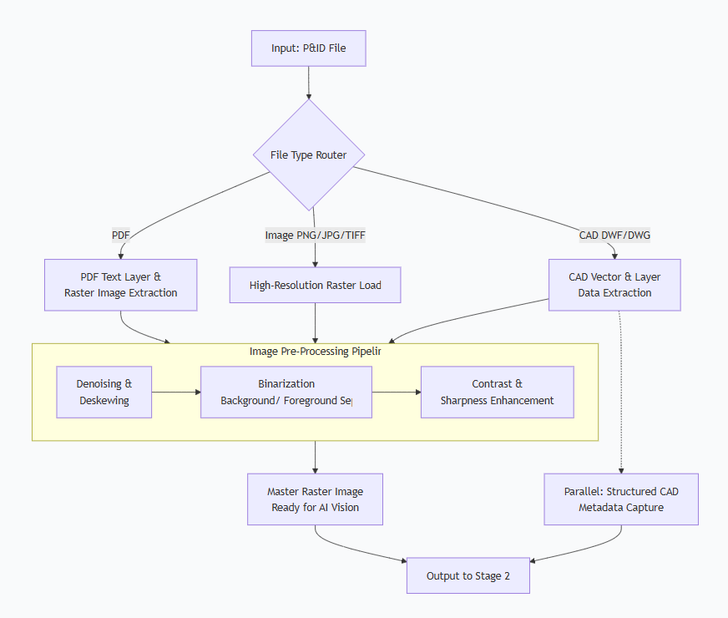
This stage prepares the heterogeneous input for consistent AI analysis.
Process Flow: Ingestion & Pre-Processing
Description:
The system first routes the input file based on its type. For PDFs, it extracts both any embedded text (which can be unreliable) and a high-fidelity raster image. For scanned images, it focuses on quality loading. For CAD files, it parses vector data and layers, which is highly valuable structural information.
The Image Pre-Processing Pipeline is critical for real-world, often poor-quality drawings. It removes scan artifacts, corrects alignment, and converts the image to a clean black-and-white format, dramatically improving the accuracy of downstream computer vision tasks. Processed raster data and any captured CAD metadata are passed to the next stage.
5. Stage 2: Vision & Symbol Recognition Layer
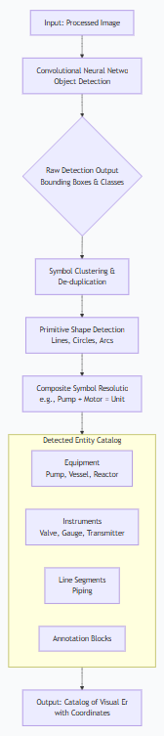
This is the core AI perception stage, where the system "sees" and classifies the components of the drawing.
Process Flow: Symbol & Primitive Detection
Description:
A pre-trained Convolutional Neural Network (CNN), trained on millions of P&ID symbols from various standards (ISA, ISO, DIN), scans the image. It outputs bounding boxes around detected objects and classifies them (e.g., "ball valve," "centrifugal pump," "flow indicator").
Post-detection logic:
- Clusters multiple overlapping detections of the same symbol into one.
- Runs lower-level geometric detection to find basic shapes that form complex assets or connect symbols.
- Resolves composite symbols (e.g., identifies a pump symbol connected to a motor symbol as a single "Pump Unit" asset).
The output is a catalog of all visual elements, their type, and their precise location on the drawing.
6. Stage 3: Text Detection, OCR & Entity Disambiguation

This stage extracts and contextualizes all alphanumeric information, which is the identity system of the plant.
Process Flow: Text to Tagged Entity
Description:
A specialized text detection model first finds every text block. A robust Optical Character Recognition (OCR) engine then converts these image patches to text strings.
The critical Tag Parsing Engine uses rule-based patterns (e.g., P-xxx for pumps, PT-xxx for pressure transmitters) and, more importantly, contextual AI to classify each text string. It determines if "101" near a vessel symbol is a tag (V-101) or a capacity annotation.
Finally, disambiguation logic definitively links each tag to its visual symbol. This creates an enriched entity: a known symbol (pump) with its assigned plant identity (P-101) and other attributes (size, service).
7. Stage 4: Relationship Mapping & Graph Construction
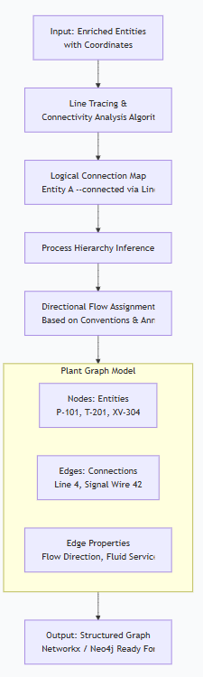
This stage infers the functional logic of the plant by determining how entities are connected, moving from a "list of parts" to a "system model."
Process Flow: From Entities to Plant Graph
Description:
Algorithms analyze the spatial coordinates of entities and the detected line primitives. They trace the path of each pipeline and signal line to determine which equipment and instruments are connected.
This connectivity data is used to:
- Build a graph network, where nodes are assets and edges are pipes or signals.
- Infer process hierarchy (e.g., this reactor feeds that separation column).
- Assign flow direction based on industry standards (flow arrows, instrument diaphragm placement) and upstream/downstream relationships.
The output is a digital graph—a mathematical model of the plant's process flow, which is the backbone of a digital twin.
8. Stage 5: Structured Data Output & Validation
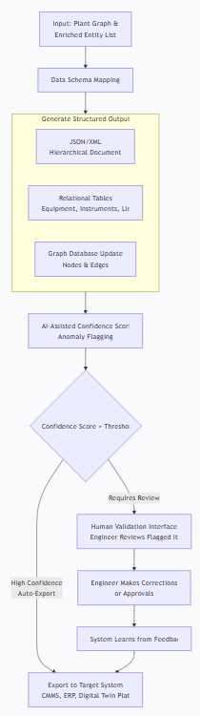
This stage formalizes the results into industry-standard formats and introduces a human-in-the-loop for quality assurance.
Process Flow: Data Packaging & Validation
Description:
The graph and entity data are mapped to a flexible but structured schema. The system can output:
- Comprehensive JSON/XML for easy integration.
- Spreadsheet-ready tables (Equipment List, Line List, Instrument Index).
- Direct updates to a graph database (Neo4j).
Before export, an AI validation layer assigns a confidence score to each extracted item and flags low-confidence extractions or logical anomalies (e.g., a pump with no connected inlet line). High-confidence data can be auto-exported. Flagged items are sent to a web-based validation interface where a human engineer makes the final call. Their corrections feed back into the AI system for continuous learning.
9. Stage 6: Integration & Downstream Application Flow
The ultimate value is realized when the structured data activates downstream digital workflows.
Process Flow: Enabling Digital Plant Applications
Description:
Hezop's output acts as a centralized, authoritative data hub. It feeds clean, structured asset and relationship data directly into core operational systems:
- CMMS: Auto-populates asset registers, enabling maintenance tasks linked to the correct P-101.
- Digital Twin: Provides the "as-designed" schematic graph to build upon with real-time data.
- APM: Allows analytics to understand how failure in one asset (P-101) impacts the connected system.
- HAZOP/LOPA: Automatically identifies nodes and guidewords, drastically reducing study preparation time.
- Master Data Governance: Synchronizes drawing data with the live plant register.
This flow closes the loop, transforming static drawings into the living data backbone of a modern, digitalized plant.
10. System Architecture & Data Flow Diagram
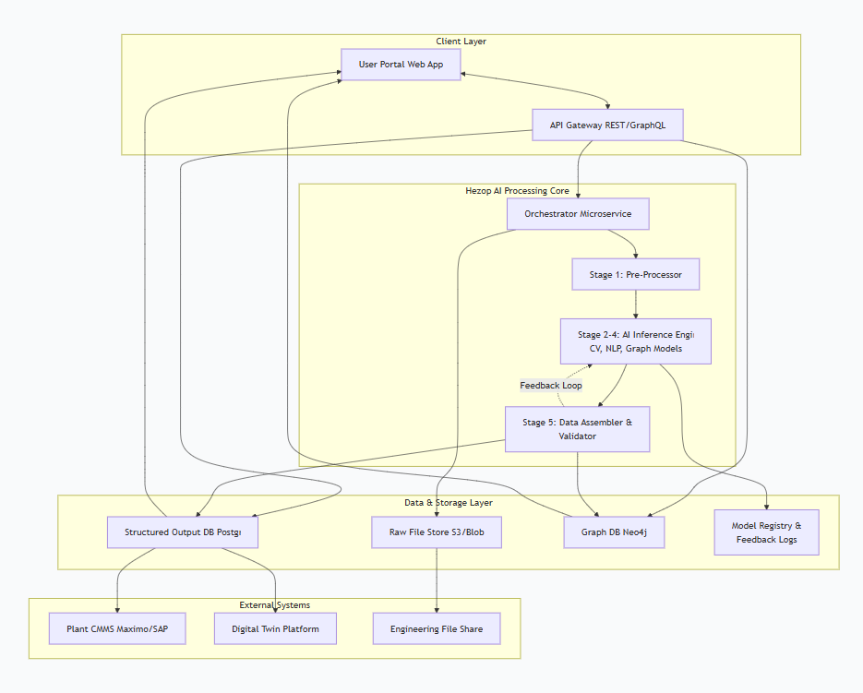
This diagram encapsulates the entire technical system that executes the process flows described above.
System Architecture & End-to-End Data Flow
Description:
The architecture is cloud-native and microservices-based for scalability.
- Client Layer: Users interact via a Web Portal or direct API calls to submit drawings and retrieve results.
- Processing Core: The Orchestrator manages the pipeline stages (1-5). The AI Inference Engine hosts the ensemble of computer vision, NLP, and graph models.
- Data Layer: Stores raw files, structured outputs in a relational database, graph models in a dedicated DB, and training feedback.
- Integrations: Clean data is pushed via APIs to CMMS, Digital Twin, and other External Systems.
Data flows bidirectionally: forward through the pipeline, and backward via the feedback loop as users validate results, continuously improving the AI models.
11. Future Roadmap & Advanced Process Flows

The current pipeline is the foundation for more advanced, autonomous plant intelligence workflows.
Future Vision: Autonomous Engineering Intelligence
Description:
- Multi-Drawing Synthesis: The next step is to automatically connect assets across an entire set of P&IDs, creating a single, unified plant master graph without manual cross-referencing.
- Reality Gap Analysis: By comparing the digitized P&ID network (the "as-designed" intent) with real-time sensor data flows (the "as-is" reality), the system can automatically identify undocumented modifications or discrepancies.
- Autonomous Engineering: The ultimate goal is an AI engineering assistant. Using the digital graph, simulation data, and operational history, it could propose optimizations, generate preliminary updated P&IDs for a change request, or automatically redline drawings against new safety standards.
12. Conclusion: The New Digital Workflow
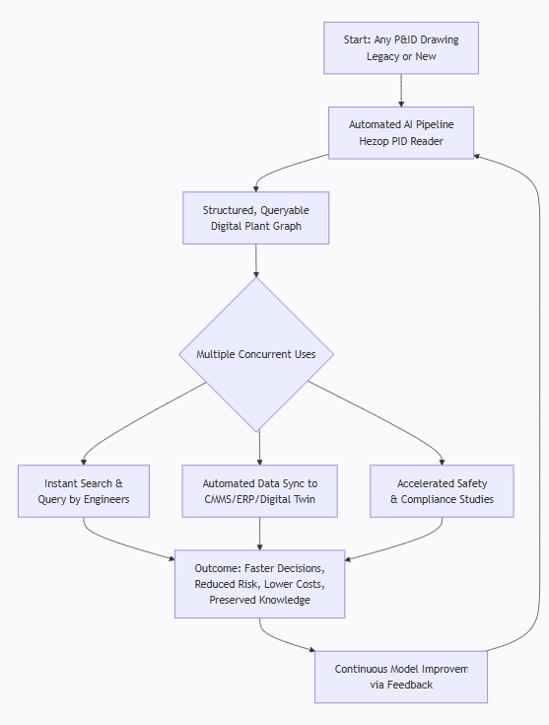
The Hezop PID Reader redefines the relationship between engineers and their most critical documentation. The new, streamlined workflow is a virtuous cycle of automation and insight.
The New Digital Workflow: A Virtuous Cycle
Final Description:
The process begins with any P&ID being ingested into the automated pipeline. Within minutes/hours (vs. days/weeks), it produces a structured digital graph. This graph simultaneously fuels:
- Engineer Productivity: Instant lookup of system relationships.
- System Integrity: Automated population of enterprise systems.
- Plant Safety & Reliability: Rapid, comprehensive engineering studies.
The result is actionable plant intelligence—reduced operational risk, significant cost savings, and the democratization of critical engineering knowledge. Feedback from all these applications continuously improves the AI, creating a self-reinforcing cycle of increasing accuracy and value. Hezop PID Reader is not just a tool for reading drawings; it is the foundational process for building a living digital brain of the physical plant.

